



**Individual Assignment**

***INTRODUCTION TO C PROGRAMMING***

**CT018-3-1-ICP**

**INFOMAX COLLEGE OF IT AND MANAGEMENT**

**HAND OUT DATE: 31 June 2022**

**HAND IN DATE*:* 4 May 2022**

**WEIGHTAGE: 40%**

**INSTRUCTIONS TO CANDIDATES:**

1. **Submit your assignment at the administrative counter.**
2. **Students are advised to underpin their answers with the use of references (cited using the APA System of Referencing)**
3. **Late submissions will be awarded zero(0) unless Extenuating Circumstances are upheld.**
4. **Cases of plagiarism will be penalized.**
5. **The assignment should be bound in appropriate style (comb bound or stapled)**
6. **Where the assignment should be submitted in hardcopy and softcopy, the softcopy of the written assignment and source code (where appropriate) should be on a CD in an envelope / CD cover and attached to the hard copy.**
7. **You must obtain 50% overall to pass this module.**

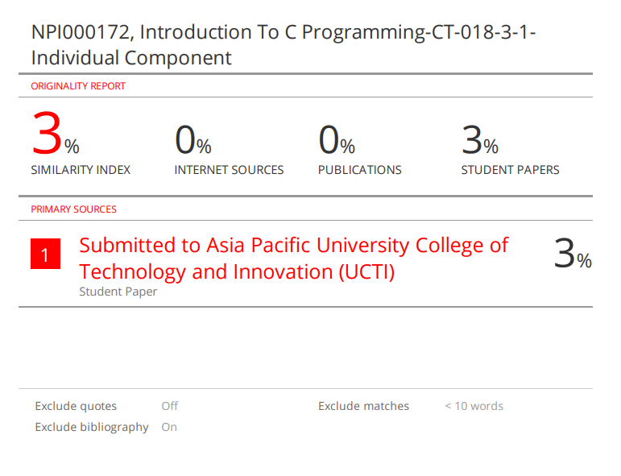

# Abstract:

Due to the outbreak of a global pandemic caused by COVID-19 which resulted in millions of death. Malaysian government to overcome the shortage in medical supplies is seeking out fundraising and donations. One of the non – profit organization (Malaysian Red Crescent Society) has been receiving supplies from various countries. So, for that reason…this particular program is built to keep track of them.

# Acknowledgement:

First and foremost, I would like to give a tremendous amount of thankfulness to our subject teacher Mr. Sushil Adhikari for his assistance and support. Without his guidance, finishing this assignment would have been lot more difficult.

**Table of Contents:**

**Assumptions: 3**

**Project Design: 4**

**i. Menu( ) 4**

**ii. Authentic( ) 6**

**iii. Mainmenu( ) 7**

**iv. Recorddonation() 9**

**v. Searchdonation() 11**

**vi. Deletedonation() 13**

**Header File Used: 15**

**User defined functions: 16**

**Additional Features: 17**

**Limitations: 18**

**Sample Output: 19**

**1. Login Screen: 19**

**2. Main menu: 19**

**2.1. Enter Inventory: 20**

**2.2. Update Record: 20**

**2.2.1. Edit Donation Record: 21**

**2.2.2. Add Donation: 21**

**2.2.3. Add Distribution: 22**

**2.3. Search Donation: 23**

**2.4. Display all Donations: 23**

**2.4.1. Display Donation Record: 24**

**2.4.2. Display Distribution Record: 24**

**2.5. Delete Donation: 24**

**2.6. Exit: 25**

**Additional Features Output: 26**

**Limited Login Retry: 26**

**Entering Same Supply Code: 27**

**Easy Navigation without exiting program: 28**

**References: 29**

# Assumptions:

The program is designed in such a way that every employee that has to access it, needs the same username and password. However, After five incorrect reattempts the program would close itself. An employee that has successfully entered the program can store new donation records, add more to existing donation & distribution records, view all donation and distribution records ordered from highest to lowest quantity, search and delete records. The program is created as such that an employee cannot use same supplycode for two different supplies.

# Project Design:

A program always begins with a pseudocode and flowchart as a working map to make the coding lot more easier and faster. Pseudocode is a simplistic description of the given program written out in a natural language line-by-line. Flowchart is the pictorial depiction of an algorithm or a pseudocode. For a simple understanding below are the pseudocode and flowchart for the program:



## Menu( )

*Pseudocode:*

* Begin
* Declare RES, c = -1, logg:
* Display the Login Screen
* Input username and password
* RES = authentic(username, password), c = c + 1
* if c >= 5 then Display “Too many attempts at login!!”
* if RES = 0 then goto logg.
* End

*Flowchart:*





## Authentic( )

*Pseudocode:*

* Start
* If username = “Admin” then

if password = “Pass” then Display “Login Successful!!” CALL mainmenu( )

else Display “Login failed - Incorrect Password!” Return 0;

end if statement

Else Display “Login failed - Incorrect Username!” Return 0

End If statement

* End the function

*Flowchart:*





## Mainmenu( )

*Pseudocode:*

* Begin the function.
* Declare choice.
* Do while (1)

Display Mainmenu Layout Screen.

Input make a choice.

Switch statement on the choice

If choice = 1 then recorddonation().

If choice = 2 then updatedonation().

If choice = 3 then searchdonation().

If choice = 4 then alldonation().

If choice = 5 then delete donation().

If choice = 6 then Display “Exiting....Goodbye ~(0v0)/” ,

Exit program.

Else print “Invalid Input, Enter value (0-6)”.

* End if statement.
* End do while loop.
* End function.

*Flowchart:*



## Recorddonation()

*Pseudocode:*

* Start the function
* Open file “donation.txt” in append & read mode.
* If file opens then

Clear Screen

Display “Enter Donation Record:”

Input Supply Code

Input Name of Supply

Input Donator

Input No. of Shipment

Input Quantity Received (in millions)

Write supplycode, name, donator, shipment, quantity to file

Display “Do you wish to continue?”

Input choice

If choice = ‘y’ then goto 3rd step

Else call mainmenu()

End if statement

Else Display ”file could not be found”

* End if Statement
* End the function

*Flowchart:*





## Searchdonation()

*Pseudocode:*

* Start
* Declare Choice, code
* Do while (1)

Clear Screen

Open file “donation.txt” in read mode.

Display “Enter Supply Code of the Record you want to search: ”

Input code.

If supplycode == code then display the record with the particular supplycode.

Else display “Such Supply Code doesn’t exist”.

End if statement.

Print “Do you want to search another record?(Y/N): ”

Input Choice.

If choice == ‘y’ then goto 3rd step

Else mainmenu()

End if statement

* End do while loop
* Close file “donation.txt’
* End function

*Flowchart:*



## Deletedonation()

*Pseudocode:*

* Start
* Declare Choice, code
* Do while (1)

Clear Screen

Open file “donation.txt” in read & write mode.

Open file “tmp.txt” in append mode

Display “Enter Supply Code of the Record you want to delete: ”

Input code.

If supplycode == code then display “record deleted”

Else write record in “tmp.txt”

End if statement.

Close file “donation.txt’, Close file “tmp.txt”

Remove current “donation.txt”

Rename “tmp.txt” to “donation.txt”

Print “Do you want to delete another record?(Y/N): ”

Input Choice.

If choice == ‘y’ then goto 3rd step

Else mainmenu()

End if statement

* End do while loop
* End function.

*Flowchart:*



# Header File Used:

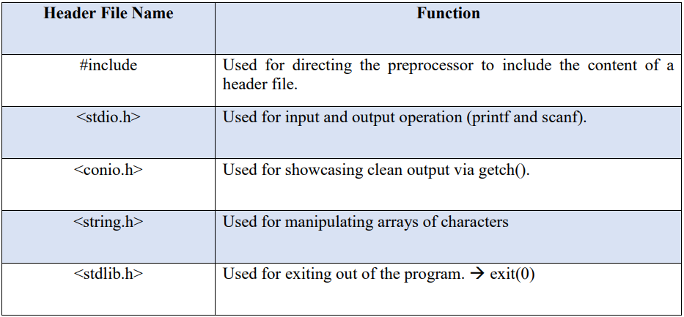

# User defined functions:

* **mainmenu()**

It is the menu screen after logging in which has all the choices ranging from creating new records to deleting them.

* **recorddonation()**

As the name suggests it records new donation supplies, however in case an employee uses same supply code twice it can also add into previously existing record.

* **updatedonation()**

This function has 4 more sub options one to edit donation records fully, two is to add quantities into existing records, three is to subtract from donation and add in distribution record and fourth one is to Segway into mainmenu.

* **searchdonation()**

The employees can search any sort of donation supply record as long as they know the supply code.

* **alldonation()**

This function allows employees to check all donation and distribution records (based on the option they chose) sorted from highest quantity to lowest.

* **deletedonation()**

This function allows employees to delete any donation supply record for whatever reason.

* **bubblesort()**

Because of this function sorting from biggest quantity to smallest is possible for both donation and distribution record.

* **donorder()**

After bubblesort sorts the values this function stores them.

* **donationlist()**

After sorting, storing and all finally this function unleashes them all and prints the record in the sorted manner as intended.

* **distorder()**

Same as donorder but this one stores for distribution records.

* **distributionlist()**

After distorder stores them in this function releases them all and prints the distributed records in the sorted manner as intended.

# Additional Features:

Here are some of the additional features outside of the minimum requirement of the given assignment added into the system to make it more easy to use and efficient.

* Limited Login Retry:

As the program is accessed only after going through the login screen, I decided to keep the retries limited i.e. 5 where the program will give “Too many attempts at login!!” text prompt and close until the program is run again (sample output towards the end).

* Easy Navigation without exiting program:

After going through the mainmenu to any of the options you can always get back to mainmenu if you want without recording, updating or deleting any record by just typing ‘exit’ making navigating in the program easy (sample output towards the end).

* User-Friendly UI

The program has clean, friendly and very easy to understand user interface.

# Limitations:

Here lies the limitations of the program:

* Limited Quantity:

As the data type used for quantity is float, it is limited by it thus you can’t record data for one supply for a long time.

* Low Security:

Because of login having a same pre-defined username and password for every employee the data security isn’t very reliable.

# Sample Output:

The following figures are the sample output for the given program:

## Login Screen:

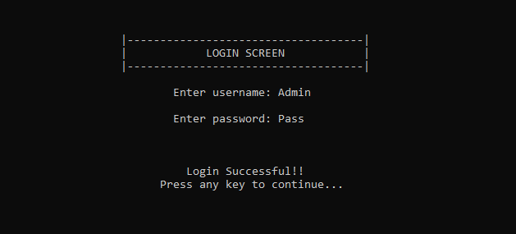

fig 1: Login Screen

**Enter Username: Admin, Password: Pass to Login Successfully into the main menu screen. The username and password are pre-defined. 🡨**

## Main menu:

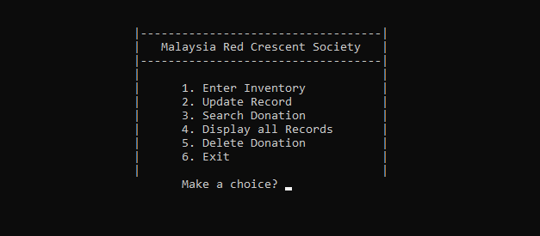

fig 2: Main menu

**After successfully logging in, the program opens the main menu screen where the user can select any operation they choose to perform. 🡨**



### Enter Inventory:

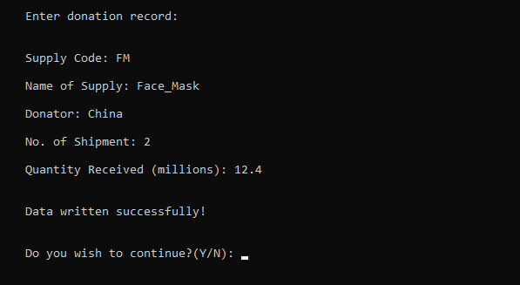

fig 2.1: Enter Inventory

**After choosing 1, users are taken to Enter Inventory screen where they are asked donation details to record into the system. Users can choose to continue recording donation details by typing ‘Y’ or ‘y’ and exit to main menu by typing ‘N’ or ‘n’. 🡨**

### Update Record:

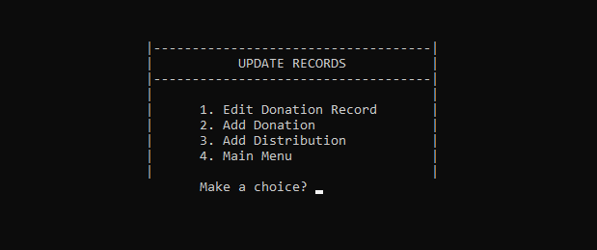

fig 2.2: Update Inventory

**If you enter 2 in the main menu, the user is taken to update records menu where you can choose whether to edit the entire existing donation record or add no. of shipment and quantity received to existing donation record or add distribution record. All the operation are carried out on an existing record using their supply code as an unique entity to distinguish among the records.**

#### Edit Donation Record:

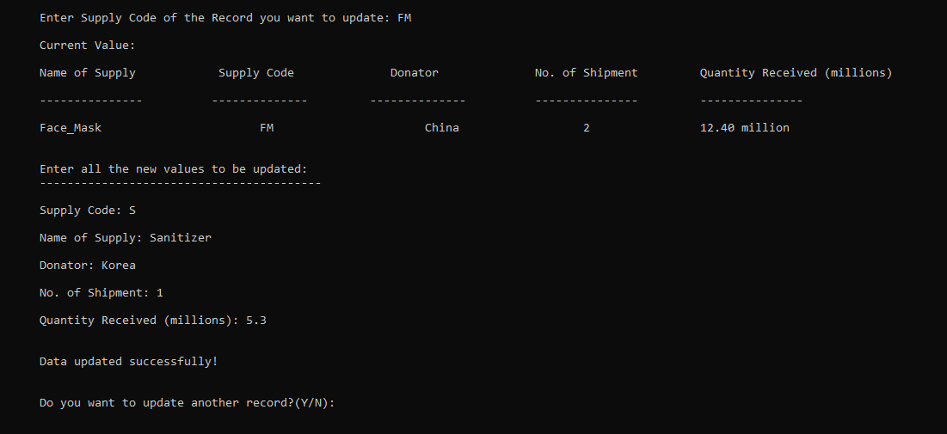

fig 2.2.1: Edit Donation Record

**Selecting Edit Donation Record, leads the user to a different screen where one can enter any existing supply code to completely edit all the details of the said donation record 🡨**

#### Add Donation:

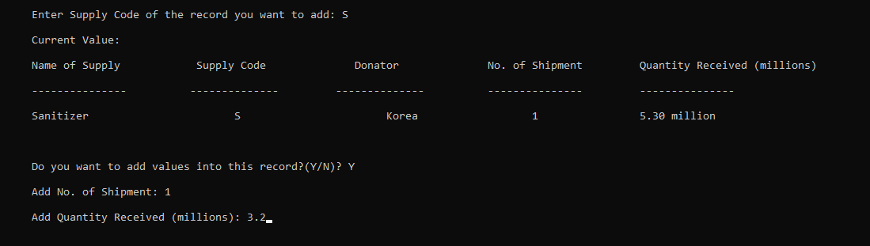

fig 2.2.2: Add Donation (Before)

**Before 🡨 In Add Donation, users can add both No. of Shipment and Quantity received to an existing donation record by using it’s Supply Code to select.**

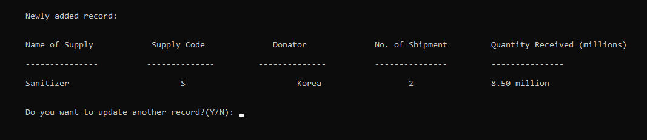

fig 2.2.2: Add Donation (After)

**After 🡨 After adding No. of Shipment and Quantity received, the program shows the newly added record.**

#### Add Distribution:

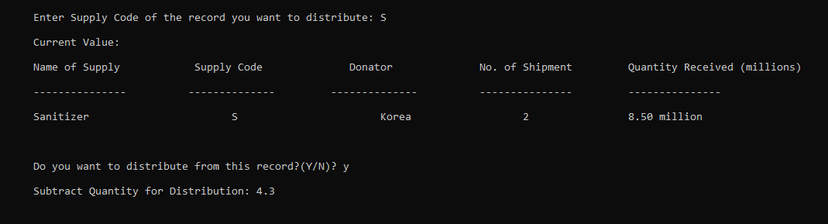

fig 2.2.3: Add Distribution (Before)

**Before 🡨 Users can add Quantity Distributed to “dist.txt” by subtracting from an existing donation record (Quantity Received) from “donation.txt”.**

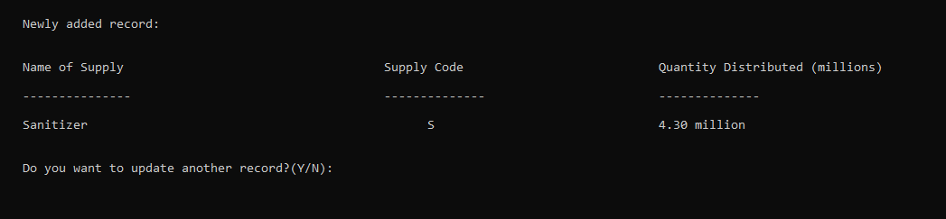

fig 2.2.3 Add Distribution (After)

**After 🡨 After adding Quantity Distributed, the program shows the newly added record.**

### Search Donation:

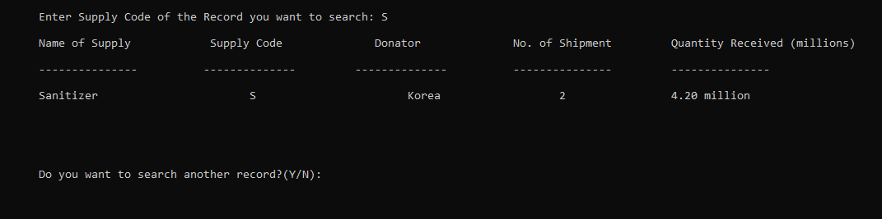

fig 2.3: Search Donation:

**After picking Search Donation from the main menu, the user is asked to provide Supply Code to search for any existing Donation Record. Users can continue searching by typing ‘Y’ or ‘y’ and exit to main menu by typing ‘N’ or ‘n’. 🡨**

### Display all Donations:

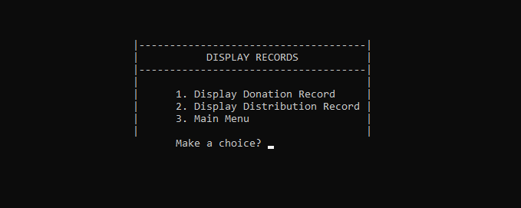

fig 2.4: Display Records

**Choosing Display all Donations, takes user to Display Records menu where users can choose whether to Display Donation Record or Display Distribution Record. 🡨**

#### Display Donation Record:

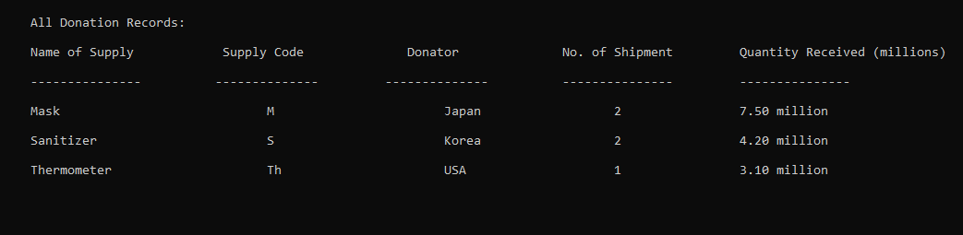

fig 2.4.1: Donation Records

**Displays all the Donation Records sorted with bubble sorting by quantity in descending order. 🡨**

#### Display Distribution Record:

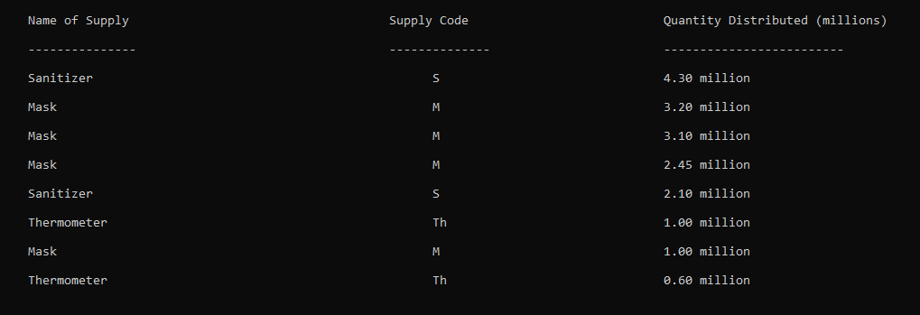

fig 2.4.2: Distribution Records

**Displays all the Distribution Records sorted with bubble sorting by quantity in descending order. 🡨**

### Delete Donation:

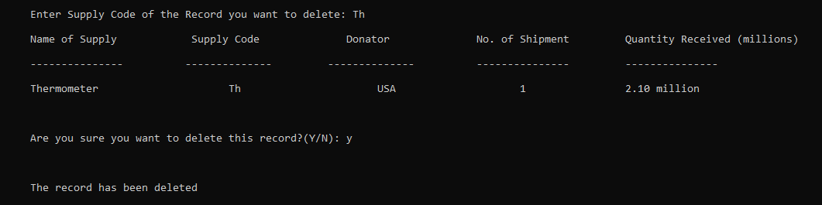

fig 2.5: Delete Donation

**After selecting Delete Donation, user is taken to a new screen where the program asks for Supply Code of the Donation Record to be deleted. 🡨**

### Exit:

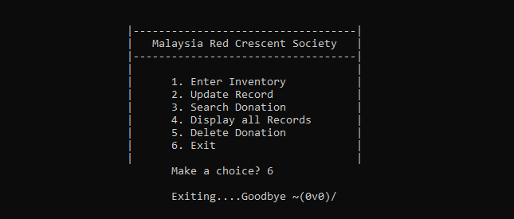

fig 2.6: Exit

**Exiting….Have a Good day 🡨**

# Additional Features Output:

## Limited Login Retry:



fig 1: Too many attempts

After attempting five retries, if the user cannot get the username and password right then the program shows the above alert screen. **🡨**

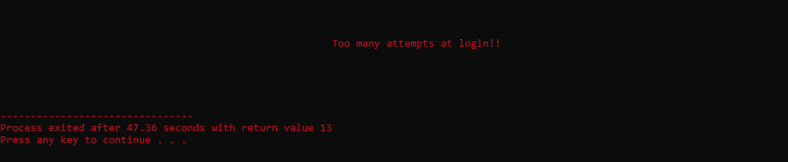

fig 2: Exiting Program

After the alert screen is shown pressing any key will exit the program. **🡨**

## Entering Same Supply Code:

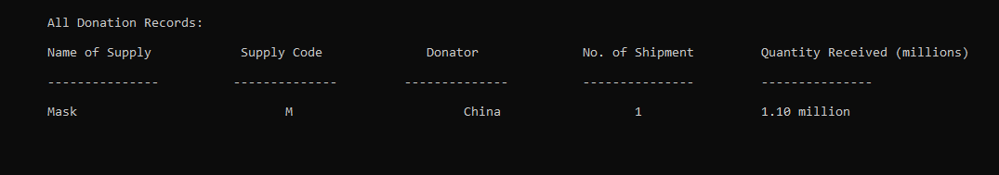

fig 3: Donation Record featuring M Supply Code

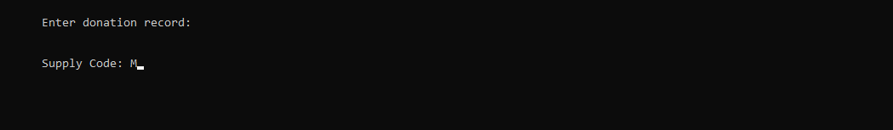

fig 4: Enter Inventory – Entering Supply Code

Here, the user enters already existing ‘M’ Supply Code in Enter Inventory. **🡨**

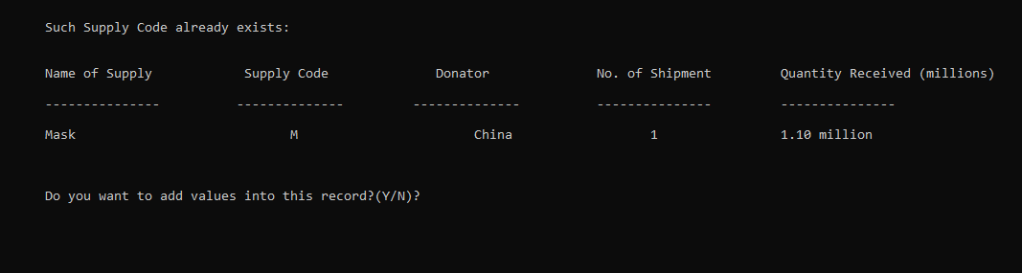

fig 5: Supply Code already exists

After entering ‘M’ Supply Code, the program takes you to a new screen from which you can choose to add value i.e. (No. of Shipment and Quantity Received) into the existing record with the ‘M’ Supply Code. **🡨**

## Easy Navigation without exiting program:

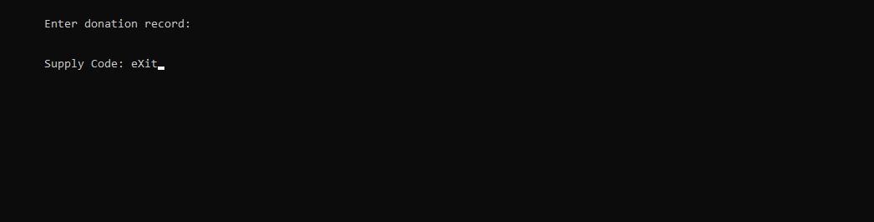

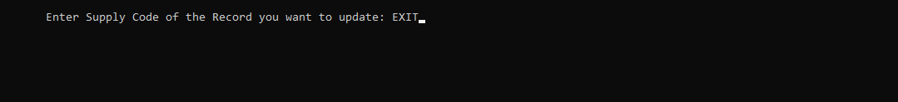





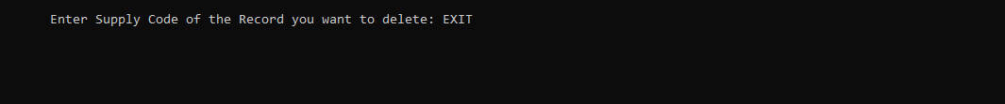

↧



fig 6: Exit to main menu

Entering “exit” in Enter Inventory, Update Record, Search Donation and Delete Donation would take you to back to main menu without performing any other action in case you accidently go to any of the menu option. Making Navigation much easier inside the program. Note: “exit” is not case sensitive. **🡨**

# References:

Kernighan, B. W., & Ritchie, D. M. (1988). The C programming language

[www.w3schools.com](http://www.w3schools.com). (n.d.). (Structures). [online] Available at:

<https://www.w3schools.com/c/c_structs.php>

E Balagurusamy, (2012). Programming in ANSI C. Tata McGraw Hill Education Team

Portfolio Courses. (2021, Sept 4). Bubble Sort | C Programming Example [Video]. Youtube. <https://www.youtube.com/watch?v=YqzNgaFQEh8&t=223s>